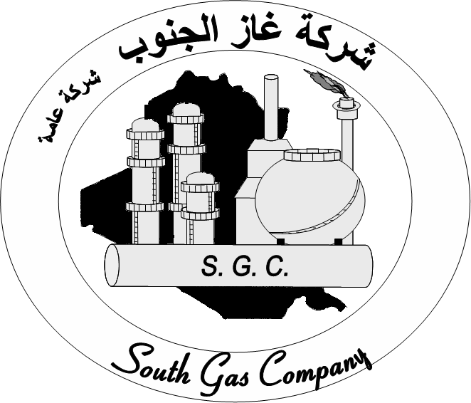
Ministry of Oil South Gas Company ( (State Company

SGC-C178-2012

SUBJECT :TECHNICAL I OFFER FOR ( NON SPARKING BOLTING TOOLS (HYDRAULIC TYPE )WITH ALL CONNECTION)
1-Complete hydraulic Nut Splitters with hand pump :
-Qt.:"2"two Set
-Capacity :5-90 Ton
-Bolt range :M12-M48
-Maximum Operating Pressure:700 bar
-Length of hose :6 m
M39-M48 | M33-M39 | M27-M33 | M22-M27 | M16-M22 | M12-M16 | Bole range (mm)
60-75 | 50-60 | 41-50 | 32-41 | 24-32 | 19-24 | Hexagon Nut range(mm)
2-Complete hydraulic flange Spreader with hand pump :
-Qt.:"2"two Set
-Capacity : 5 – 10 Ton
-Maximum Operating Pressure ; 700 bar
-Length of hose :6m
Capacity  \(ton) | Standard wedge  (mm) | Stud size  (mm) | Maximum flange thickness (mm)
5 | 3-28 | 19-28 | 2x57
10 | 3-28 | 31-41 | 2 x 92
3-Complete hydraulic wedge spreaders with hand pump & safety block :
-Qt.:"2" two Set
-Tip clearance :6mm
-Maximum spread :6mm/81mm .
-Maximum spread force :14 ton
- Maximum Operating pressure :700 bar
-Length of hose : 6m
4-Flange Alignment tools:
-Qt."1" One Set
-Bolt hole range "17-54" mm
-Maximum lifting force :3 ton
Notes :
1-Origin :West Europe .
2-Training Course for two technicians in country of origin (One week ) .
3-Catalogues needed , otherwise ,offers will be not identical .
4-Origin certificates when supplying materials .

